A data-driven approach to evaluate spatiotemporal changes in fish size, with application to NE Pacific Sablefish

Kapur, M., Haltuch, M., [others] Punt, A.

Keywords: growth, von Bertalanffy, stock assessment, sablefish, spatial variability

# Abstract

Renewed interest in the estimation of spatial variation in fish body size is a result of computing advances and the development of spatially-explicit management frameworks. However, many attempts to quantify spatio-temporal distribution of traits utilize *a priori* approaches, which involve pre-designated geographic regions and thus cannot detect unanticipated trends. This study presents a new, data-driven method which evaluates the first derivative of spatio-temporal generalized additive model to identify spatial and annual break points in fish length-at-age. We use simulation testing to illustrate the robustness of the method across a variety of spatio-temporally complex age and length data, and apply it to survey data of Northeast Pacific sablefish (*Anoplopoma fimbria*). Preliminary results indicate that some parameters of the von Bertalanffy growth function show an increase with latitude in the NE Pacific, which is consistent with work done in the western United States; simulation testing illustrates the robustness of the method across a variety of spatio-temporally complex growth data. This method has the potential to improve detection of large-scale patterns in fish growth, and aid in the development of structured population dynamics models.

# Introduction

Renewed interest in the construction of spatially-explicit management frameworks (Thorson et al., 2015), and advances in computing power have motivated efforts to quantify spatial variability in fish size for managed species, including Gulf Sheepshead (Adams et al., 2018) and northern rock sole (Hurst and Abookire, 2006), as well as groundfish of the western United States (Gertseva et al., 2017; James et al., 2002; Mason et al., 1983). Understanding demographic variation of this key trait (somatic growth) can improve the precision of fisheries assessment (Punt, 2003; Stawitz et al., 2019).

In fisheries management, somatic growth rates are typically generated using the von Bertalanffy growth function (VBGF, von Bertalanffy, 1957) or an alternative method, with parameters derived using model-fitting procedures. The resolution of the resultant estimates is necessarily predicated on the spatio-temporal aggregation of the data, which is often defined by survey stratification and/or changes in sampling gear. For example, Alaska federal and state sablefish fisheries generated separate VBGF parameter estimates for two periods of survey data based on the *a priori* hypothesis that changes in gear type would affect fish growth estimates from survey data (Echave et al., 2012; Hanselman et al., 2017; McDevitt, 1990), and imposed a time block between which the growth coefficients were actually quite similar (see Table 2). Even more sophisticated approaches which utilize hierarchical Bayesian methods to estimate latitudinal and regional effects on length- or weight-at-age require a design matrix of dimensions dictated by pre-supposed zones (Adams et al., 2018). Such approaches are useful within a rigid management context, but do not handle the underlying growth process explicitly, and preclude the discovery of spatio-temporal trends in fish size that violate management boundaries.

Numerous attempts to quantify somatic growth variation typically face a trade-off between superimposing previous beliefs about stock structure (as in the Alaskan example above) or generating purely descriptive models of trait ‘gradients’ across regions or time periods, without a clear method to define significant break points within them. This presents a gap for management scientists, who wish to build population dynamics models that accurately represent the population structure of managed stocks. The ideal tool is a data-driven method which defines significant break points in fish size, which researchers can then use to aggregate and estimate parameters of somatic growth. Our approach, which evaluates the first derivative of smooth functions from a generalized additive model (GAM), meets this objective in a simple, rapid computational framework. Fisheries scientists are likely already familiar with GAMs, and the method does not require the specification of multiple error structures nor the construction of spatial meshes, which can be computationally expensive when large (Thorson, 2019a). The analysis of first derivatives in GAMs for change-point analysis has recently used in terrestrial paleoecology (Simpson, 2018) and geophysics (Beck et al., 2018).The objective of this study was to develop a method for detecting change points in spatiotemporally complex fisheries growth data and which minimizes the use of pre-supposed spatial stratifications in the analytical approach. This method has the potential to improve detection of large-scale patterns in fish growth, and aid in the development of structured population dynamics models. We use simulation to test the robustness of the method to increasingly complex spatio-temporal age and length data, and present a case study application to northeast Pacific sablefish (*Anoplopoma fimbria).*

# Methods

We developed a data-driven analytical approach to detect changes in fish growth, tested the model on simulated data, and then applied the model to a commercially harvested groundfish stock in the Northeast Pacific. The method was designed to identify significant spatiotemporal break-points in the age-length relationship and not consider *a priori* hypotheses of spatial stratification.

The method involves fitting a Generalized Additive Model (GAM) using the mgcv package (Wood, 2011) in R (R Development Core Team, 2011) to the vector of observed lengths as the response variable, predicted by separate smoothers for year and latitude.

Equation 1 $g\left(μ_{t}\right)=β_{0} +f\left(x_{t}\right)+f\left(s_{t}\right)+a_{t}+ϵ_{t}$

Where µt represents the expected mean of fish length, which is a random variable of which we have *t* observations; the linear effects of fish age ($a_{t}$) and latitude ($s_{t}$) and year ($x_{t}$), the last two of which are smooth functions. *g* is an invertible, monotonic function which enables mapping from the response scale to the scale of the linear predictor, such as the natural logarithm.

The first derivatives of the GAM are evaluated to identify areas of significant change (i.e., break points) in growth parameter estimates. Once the best-fit model was identified, we used the method of finite differences (as in Simpson, 2018) to locate time periods and/or locations where fish size is changing the most. The finite differences approach approximates the first derivative of the spline generated from the GAM function. For instance, the vector of derivatives **G** for latitude is produced via:

Equation 2 $G=\frac{g\left({s^{'}}_{t}\right)-g(s_{t})}{ε}$

Where $g\left({s^{'}}_{t}\right)$ is a vector of predicted points from the GAM along a set of new latitudes, defined by the user as $s_{t}+ε$, or the original points in the dataset plus a small, uniform change. The resultant matrix returns values for the linear spatial predictor of the model with other effects (year) held constant. Vector **G** is of the same length of the observed dataset.

The uncertainty in derivative estimates are computed via:

Equation 3 $standard error of derivatives= {\left[\sum_{1}^{i}{(G{V)}_{i}}\right]}^{1/2}$

Where **V** is the covariance matrix for each of *i* parameters of the current GAM spline (typically just one, though multiple terms in a single smooth are feasible); the square root of the sum of this matrix provides the standard error for each derivative estimate of the spline.

We then identify years or latitudes where the confidence interval of the first derivative was outside the 5th to 95th percentiles of the entire set of derivatives **G** and do not include zero. We designated these as “break points”. Once identified, we re-aggregate the raw length and age data to match these breakpoints and estimate the parameters of the VGBF (*L∞* - asymptotic length, *k* - the rate at which asymptotic length is approached and *t0* - the estimated age at length zero) using maximum likelihood in Template Model Builder (Kristensen et al., 2016) under the assumption that the error term is lognormally distributed with zero mean and variance σ. Because the parameters of the VGBF can be highly negatively correlated, we subset real and simulated datasets used here to include only female fish of age four.

Equation 4 2)

The growth curve was fitted separately for each sex, resulting in estimated values for the three growth parameters for each spatiotemporal stratum by sex; the additive error term is normally distributed with mean zero.

Initial parameters were t0 = 0.1, $σ$ = 0.1, with L∞ = 150, K = 0.1.

Below, we detail the simulation testing and case study used to demonstrate the method’s effectiveness at detecting change points in fish size.

## Simulation Testing

We performed a simulation study to evaluate the robustness of the proposed method, using datasets generated using an individual-based model (IBM). The IBM is capable of mimicking individual characteristics by following the life history processes (survival, growth, and reproduction) of individual fish. We simulate spatial variation by generating length and age datasets under different growth regimes (i.e., higher values of *K* and $L_{∞}$) and assign a range of latitudes to each regime. The growth module of the IBM itself implements a VBGF with *L*1 and *L*2 as in Stock Synthesis (Methot and Wetzel, 2013):

Equation 2 $L_{∞}$ = $L_{1}+\frac{(L_{2}-L_{1})}{1-exp⁡(-K×(a_{2}-a_{1})}$

Where $L_{1,2}$ represents the length of a fish at age $a_{1,2}$, and K is the same as in Equation 1. An individual fish’s growth increment is subject to a bias-corrected lognormal error term. Depending on the scenario, the different $L_{∞}, K$ regimes are either assigned completely distinct latitudinal ranges or ranges with some overlap.

The simulated scenarios described below were designed to represent a variety of of possible regimes in spatial growth variation. Under each scenario, we generated 100 replicate datasets, and tabulated the frequency at which a given break point was identified using the GAM method described above. The method was evaluated based on a) if it was able to accurately detect the presence or absence and location of ‘break point(s)’ in space, and b) if re-aggregation of the data at the proposed break point resulted in VBGF parameter estimates that overlapped with the true values used to generate the dataset at the appropriate resolution.

|  |  |
| --- | --- |
| **Scenario Description** | **Spatial Stratification** |
| No spatial breaks | Latitude is uniform random variable for all points |
| Single, symmetrical spatial break in middle of range, with no overlap | Latitude ~ U[0,25] for growth Regime 1; Latitude ~ U[25,50] for Regime 2 |
| Single spatial break at edge of range with no overlap | Latitude ~ U[0,49] for growth Regime 1; Latitude ~ U[49,50] for Regime 2 |
| Single spatial break with some overlap | Latitude ~ U[0,25] for growth Regime 1; Latitude ~ U[20,50] for Regime 2 |
| Spatial expansion/contraction | Regime 1 Latitude ~ U[1,50] in year one, and moves ‘northward’ one degree each year. In year 50, Regime 2 ~ U[1,49] and Regime 1 ~ U[49,50] |

Table 1. Summary of simulated datasets used to test method in presence/absence of spatiall variation in growth. Regime 1 refers to a central Pacific billfish-like species, where Linf = 220 and K = 0.258; Regime 2 Linf = 350, K = 0.45.

For each simulated dataset, we constructed a GAM function as described above, utilized the method of finite differences to identify time periods and/or locations where growth was changing quickly (where the confidence interval of the first derivative was outside of the 5th to 95th percentiles of the entire derivative set for that simulation, **G** and did not include zero). The data were then re-aggregated to match the most frequently identified spatial break point for that dataset, and fit to a VGBF in TMB to provide estimated life history parameters Linf and K.

## Application to Northeast Pacific Sablefish

Sablefish (*Anoplopoma fimbria*) are a highly mobile, long-lived, valuable groundfish that have high movement rates (10 – 88% annual movement probabilities across Alaska, Hanselman et al. 2015) and range from Southern California to the Bering Sea. Concurrent population declines across the entire range during the past few decades have increased concern about the status of sablefish and interest in the causes of the downward trend. Traditionally, sablefish stock assessment and management has occurred independently at regional scales, namely Alaska, British Columbia, and the US West Coast, assuming that these are closed stocks. However, recent genetic work has shown that NE Pacific sablefish are not genetically distinct between these traditional management areas (Jasonowicz et al., 2017), though there is evidence for differences in growth rate and size-at-maturity throughout the range (McDevitt, 1990). This suggests that the current delineation of assessment and management regions is incongruent with the stock’s actual spatial structure and motivates research that would enable the construction of a population dynamics model that represents the spatial heterogeneity of sablefish throughout their range.

Estimates of the parameters of the growth curve for sablefish are usually based on survey data acquired from chartered commercial trawl or longline vessels (Table 1). It is preferable to obtain estimated growth parameters using data from a survey, because fishery-dependent information can be heavily biased due to targeting or gear selectivity (Ricker, 1969).

Though a robust volume of survey data is available for this species for all management regions, researchers have not yet analyzed available length and age data for the entire sablefish range for evidence of spatial patterns.

We obtained fishery-independent length and age data from the Alaska Sablefish Longline Survey and the U.S. West Coast Groundfish Bottom Trawl Survey conducted annually by the Alaska Fisheries Science Center and Northwest Fisheries Science Center, respectively. We also obtained length and age records from the Canadian Department of Fisheries and Oceans, which has performed an annual trap-based survey since 1991. Data from each region included measured length, sex, age, and the starting latitude and longitude which determined the survey station. Due to computational constraints, and to avoid disproportionate influence of more heavily-sampled regions, we randomly subsampled 8,239 records from each of the three management regions.

In constructing the GAM, we investigated the use of an AR1 temporal structure with lags of 1 to 3 years, but these models did not improve AICc over the initial model without autoregressive structure.

Once the best-fit model was identified, we used the method of finite differences (as in Simpson, 2018) to locate time periods and/or locations of statistically significant change in growth. The finite differences approach approximates the first derivative of the spline generated from the GAM function as described above. We calculated uncertainty in derivative estimates by computing the sum of the square root of the fixed-effects covariance matrix. We then identified years or latitudes where the confidence interval of the first derivative was outside the 5th to 95th percentiles of the entire dataset and designated these as “break points”. Once identified, we re-aggregated the raw length and age data to match these breakpoints and estimated the parameters of the VGBF using maximum likelihood in Template Model Builder (Kristensen et al., 2016). This was performed separately for each sex.

The VBGF is parameterized by *L∞* (asymptotic length), *K* (the rate at which asymptotic length is approached) and *t0* (the estimated age at length zero). The prediction for length at age $\hat{L_{i}}$ is subject to an error term ε that is assumed to be lognormally distributed with zero mean and variance σ. Our model estimates values for the three biological parameters at each spatiotemporal strata for two sexes; the additive error term is assumed universal across strata and sex and normally distributed with mean zero.

Equation 3

2)

We executed a maximum of 1000 iterations. Initial parameters were t0 = 0, $σ$ = 0, with L∞ = 70, K = 0.

# Results

## Simulation Study

|  |  |  |
| --- | --- | --- |
| **Scenario Description** | **True Break Points** | **Most commonly detected break (proportion)** |
| No spatial breaks | None | None (0.82) |
| *Spatial Breaks* | | |
| Single, symmetrical spatial break in middle of range, with no overlap | 25° Latitude | 25° (0.25) |
| Single spatial break at edge of range with no overlap | 49° Latitude | 49° and 50° (both 0.27) |
| Single spatial break with some overlap | Between 20° and 25° Latitude | 23° (0.32; 0.92 between 20° and 25°) |
| Spatial expansion/contraction | Varies between 1° and 49° from year to year |  |

Figure 1 Results of simulation analysis. Each row corresponds to a tested scenario; left-hand panels show a frequency histogram of latitudinal break points identified via the GAM analysis, with vertical dashed lines indicating the underlying true break point. Right-hand panels (second and third columns) compare the original and fitted life history parameters (Linf and K) used to generate the data (red points) and estimated post-aggregation (black points). Error bars represent 95% confidence intervals.

## Application to NE Pacific Sablefish

Our best-fit GAM produced a positive definite Hessian and converged after 10 iterations. It explained 42.4% of deviance. The latitude smoother suggested a generally increasing cline in length at age with latitude, with a significant breakpoint centered around 49˚N (approximately Vancouver, Canada), which corroborates results in Gertseva et al. (2017). The temporal smoother did not exhibit a strong one-way trend, though the quantile analysis identified a significant change in slope centered on years 2004-2005 (Figure 3). We therefore split the data collected during or after 2005 (hereafter referred to as “late”; prior data is “early”) and at 49˚N (hereafter referred to as “north”; data collected south of this point is designated as “south”). Parameter estimation in TMB for the VBGF generated estimates for mean and standard deviations of *t0*, log(*k*) and log(*L∞*) for unique combinations of north/south, early/late and male/female populations, and associated predictions for length at age (Figure 4). The error term was estimated to be 6.13 (standard deviation = 0.027). Across spatiotemporal strata and sexes, there was considerable overlap in parameter estimates for the growth rate *k,* whereas *L∞* and its confidence intervals were spread out at the stratification indicated by the GAM derivative analysis (Figure 5).

# Discussion

It is evident from this and previous work that there is some level of variation in sablefish growth, whether in the growth rates themselves or the spatiotemporal scale at which growth anomalies occur. Mis-specification of growth within stock assessment can overestimate management quantities, particularly the estimate of stock depletion (). Correctly-specified growth variation in the estimation model can reduce uncertainty by correctly attributing process error to somatic growth anomalies. The purpose of this study was to define the ideal spatiotemporal scale at which to structure growth for future use in a range-wide operating model of sablefish population dynamics.

Previous work with sablefish data has utilized an *a priori* approach, wherein length data were aggregated into pre-hypothesized spatial zones and compared via Akaike’s Information Criterion. This ‘information-theoretic’ (Guthery et al., 2003) approach is fairly straightforward computationally, and has been implemented separately for the California Current (Gertseva et al., 2017) and Alaska federal and state sablefish fisheries (Echave et al., 2012; McDevitt, 1990). The CC analysis identified a statistically significant break in von Bertalanffy growth parameters for sablefish at approximately 30 degrees N, between Point Conception and Monterey, CA, with additional evidence for an increasing cline in L∞ with increasing latitude. That work also observed an increase in *k* estimates for populations sampled in the Vancouver region (ca. 49˚N), which was posited to be the result of samples coming from the “southern end of a faster-growing northern stock”, a suggestion supported by our findings. The authors of that study described how sablefish have been shown to be highly migratory, with ontogenetic movements off the coastal shelf; such combined, complex life patterns could yield higher growth rates in northern regions that interact with a more generalized shelf-slope pattern observed in groundfish overall. For Alaska, a generalized linear model of length as a function of pre-specified zones and time blocks was used to diagnose a ‘regime change’ in sablefish growth occurring in 1995, though the authors explain this shift is possibly attributable to changes in sampling strategy that occurred in that year’s survey. In the recent AK sablefish assessments, the parameters of the VBGF are time-blocked accordingly (see Table 1) despite caution that the change is not inherent to the population, but likely an artifact of sampling methods. In our analysis (which included data for all regions), the first derivative was not zero in 1995 though it was not of enough magnitude to pass the quantile filter. **[Further discussion of sablefish movement following tagging analyses by Luke Rodgers, DFO postdoc].**

The consideration of temporal variation in sablefish growth is further complicated by the exploitation history of the fishery, which has steadily marched north- and west-ward over the last several decades, encountering ‘larger’ fish with subsequent expansion (M. Haltuch, pers. comm.). This suggests that differences in mean length across the region could be attributable to different degrees and durations of fishing pressure, and not inherent population differences alone. Importantly, the L∞ estimates for both sexes and regions show a decline from the ‘early’ to ‘late’ periods, resulting in nearly equivalent values for north and south regions for females and males, respectively. Simulation work by Stawitz et al. (2015) sought to model growth anomalies in sablefish (among other groundfish) as a process driven by variation in either annual, initial size or among cohorts. Data was partitioned between the CC and two regions of Alaska, and it was determined that annual-scale anomalies were more pronounced in the CC whereas the initial normalized length within each cohort explained more variation in Alaska. A principal conclusion was that the form of growth variation differed among ecosystems, wherein the CC is a more climactically variable region, which could explain why annual deviates were best for fitting to this data. Such ecosystem-driven trends may be diluted when analyzing the data as a composite, as in our study; notably, our temporal smoother did not produce a distinct annual cyclic trend. Methods that consider the space and time components co-dependently (as in vectorized auto-regressive spatio-temporal models, Thorson, 2019) may strengthen the ability to disentangle such trends, and also to consider spatial effects beyond simple latitude (e.g. near- and offshore).

# Figures

Figure 2. Histogram of raw length data from three regional surveys, colored by sex.

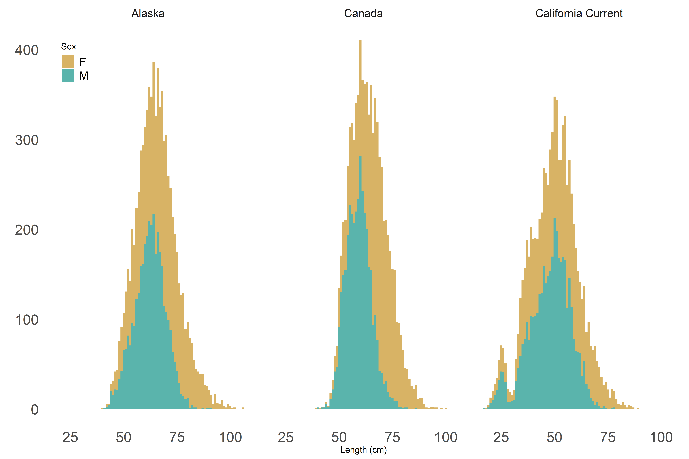

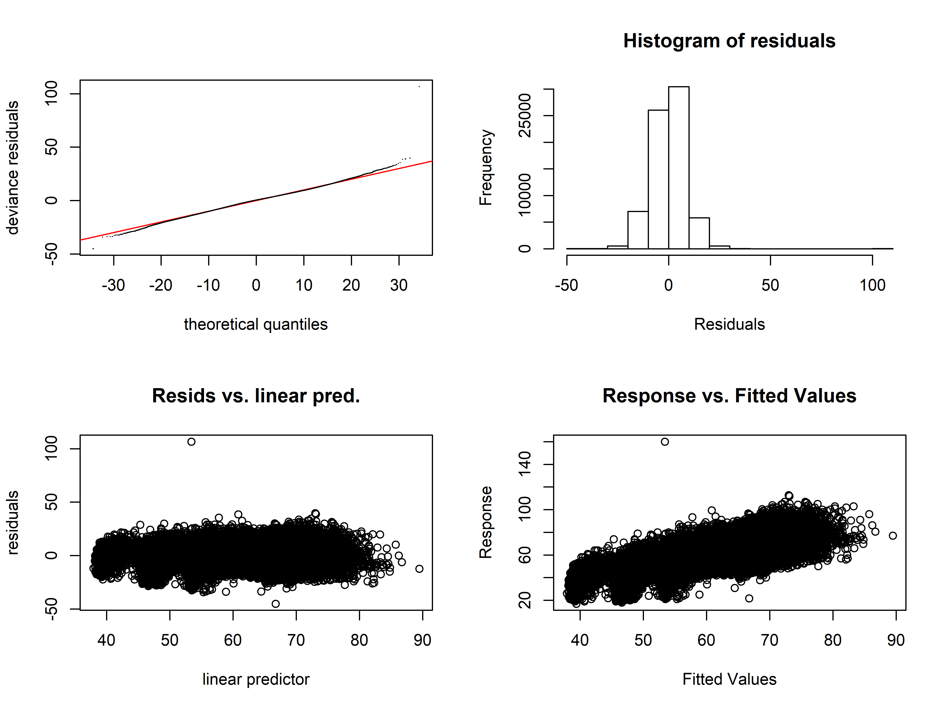

Figure 3. Diagnostic plots of best-fit GAM model. Clockwise from top left: quantile-quantile plot of deviance residuals; histogram of residuals; observed response values (lengths, in cm) vs predicted values, and model-predicted residuals vs linear predictor.

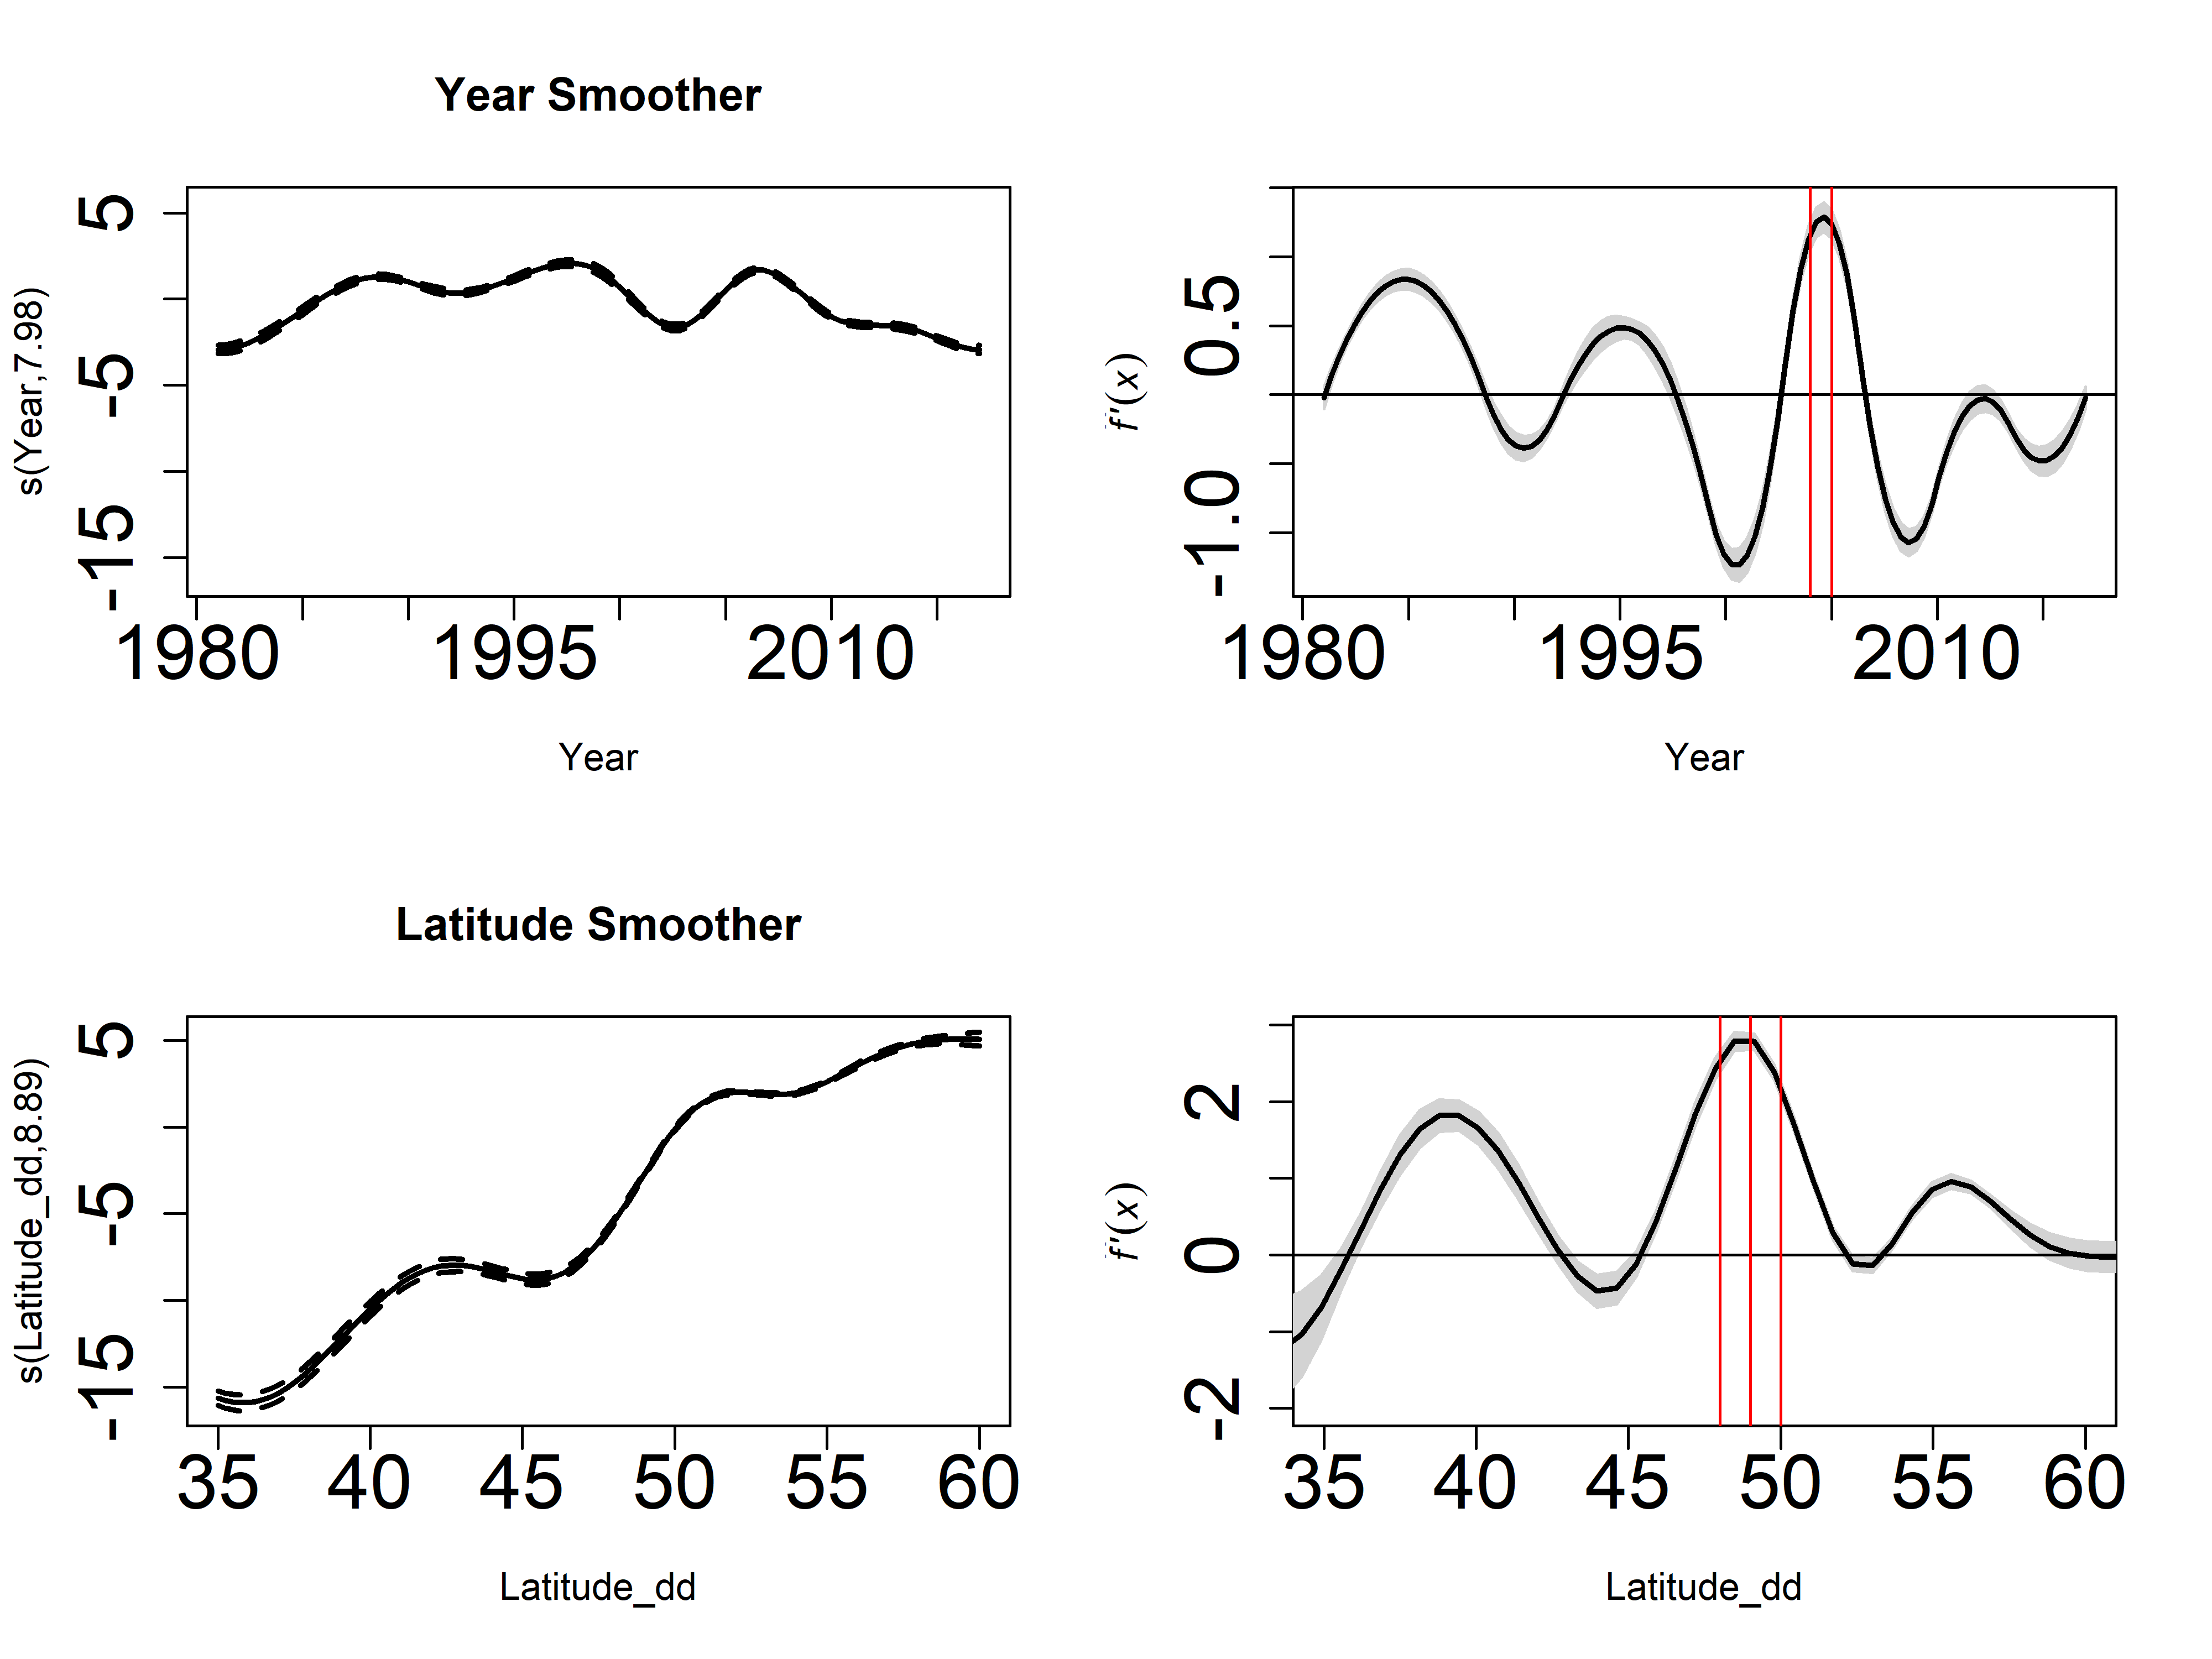

Figure 4. Plots of smoothers for Year and Latitude, and first derivatives thereof. Red lines indicate years or latitudes where the value of the first derivative was outside of the 95th percentile of values in the dataset.

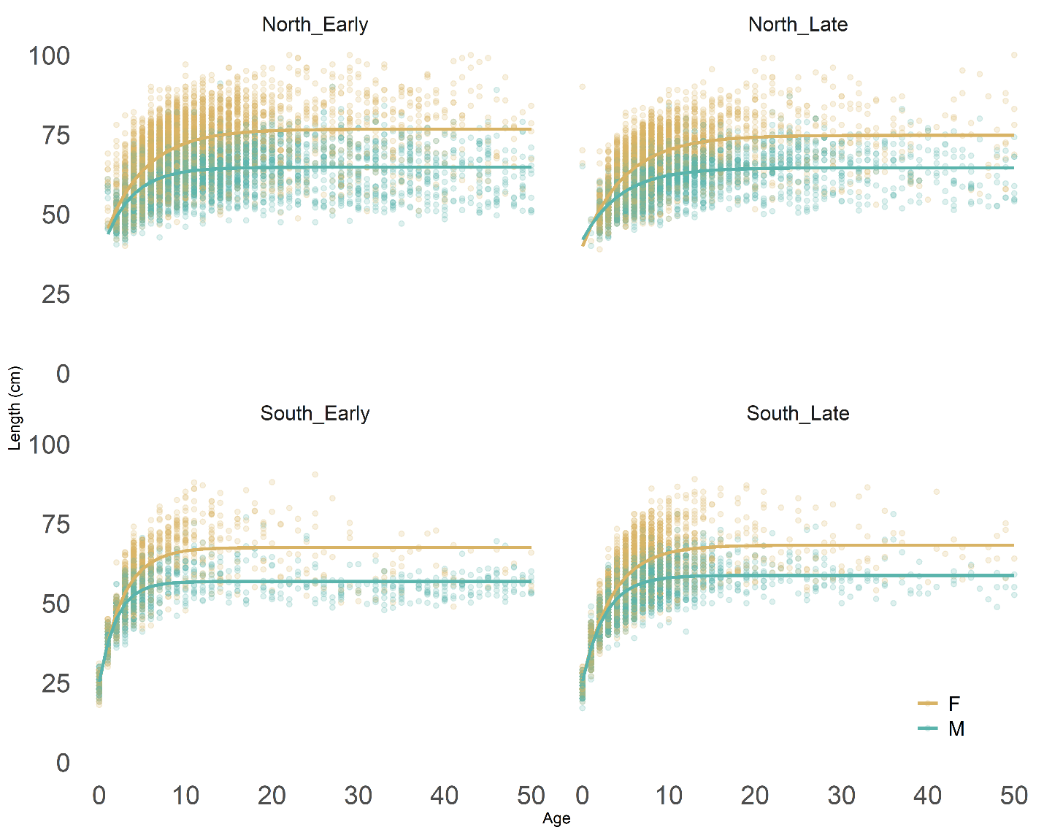

Figure 5. Fits of von Bertalanffy growth function to data stratified at values determined using the derivative analysis of the GAM. Panels marked “early” are data obtained prior to 2005; “Northern” datapoints were collected north of 45˚N latitude. Predicted values are color-coded by sex.

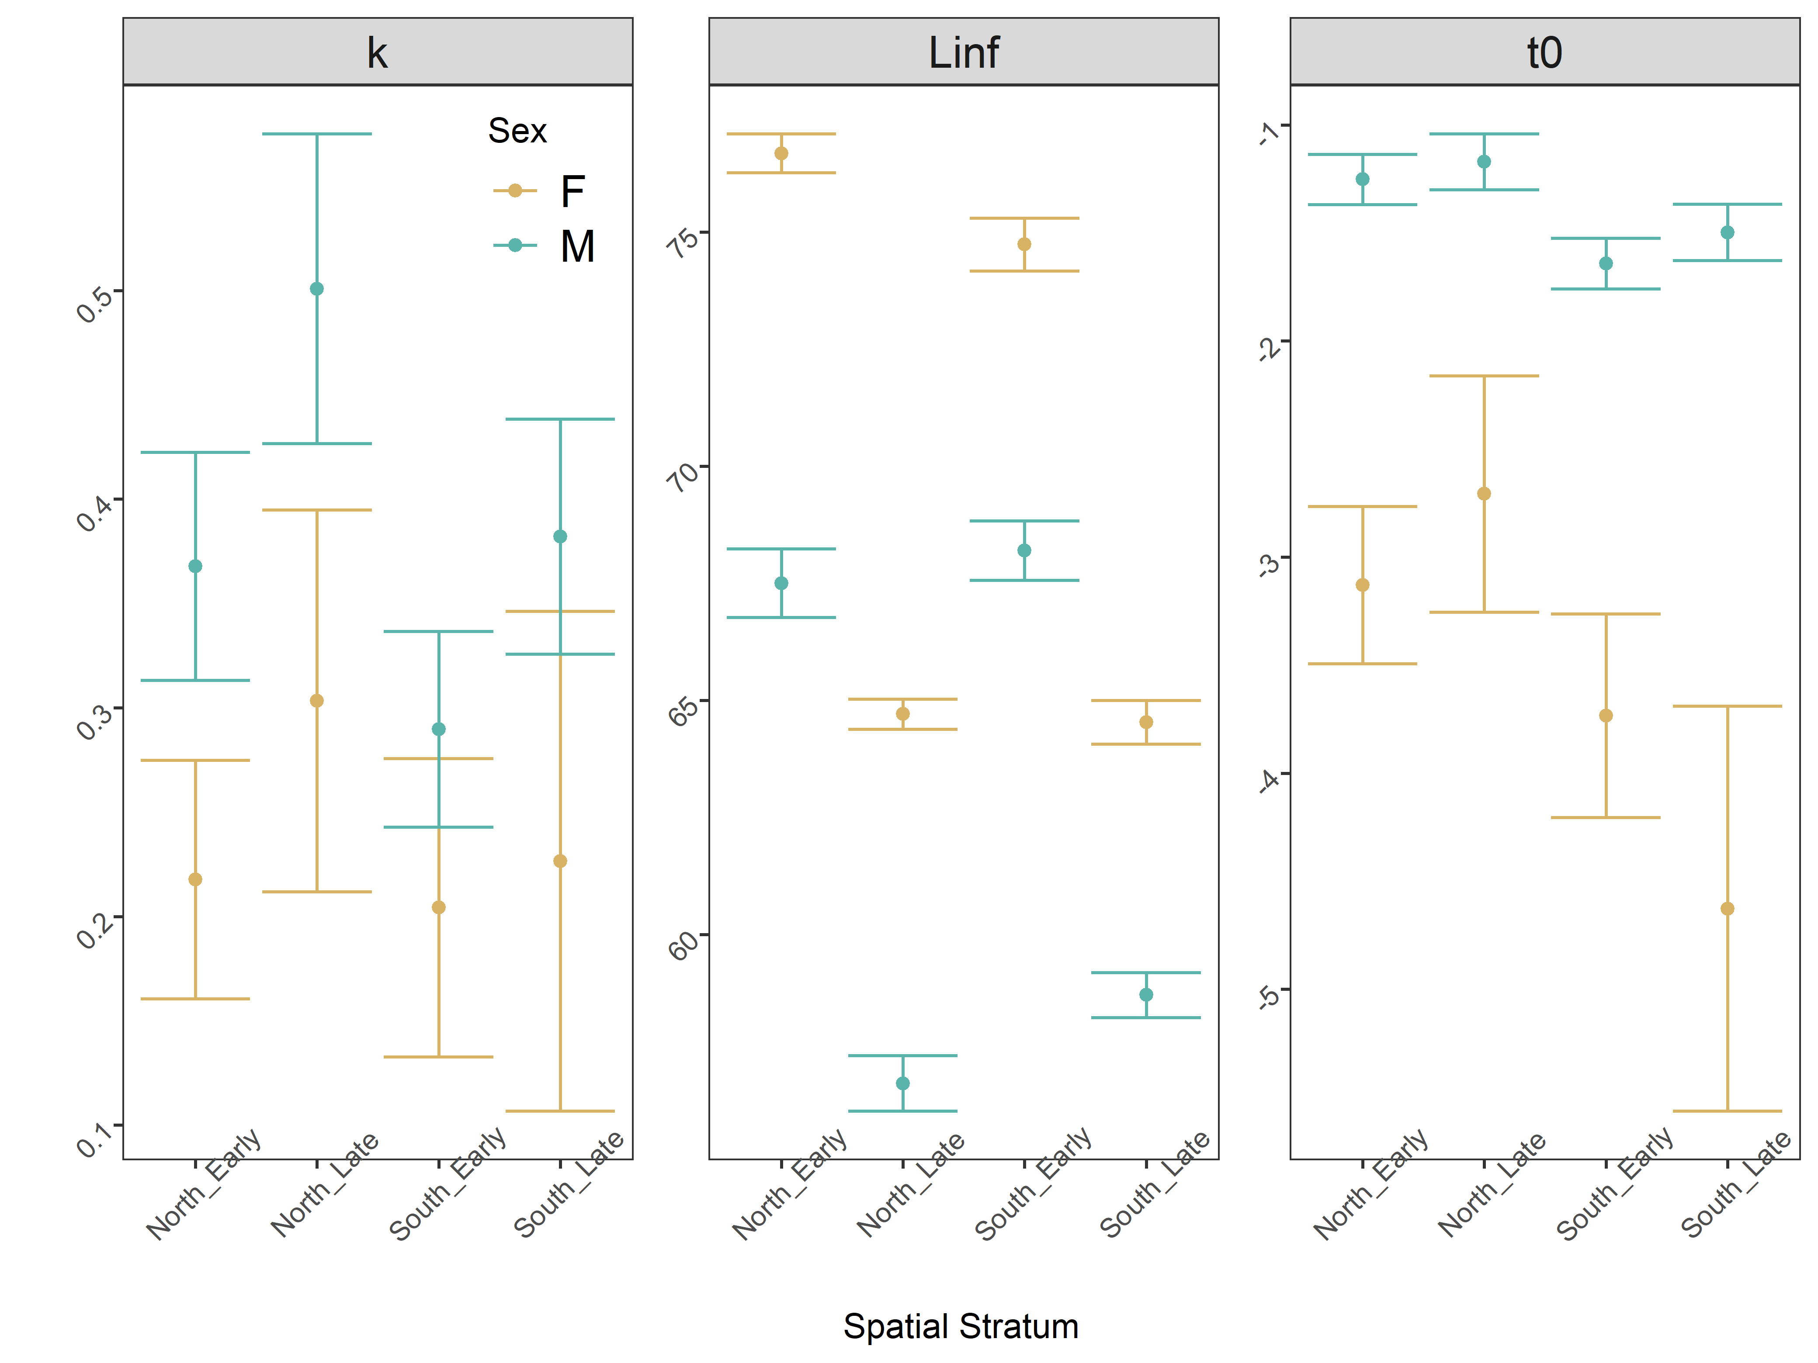

Figure 6. Comparative boxplot of estimated parameters from spatiotemporally stratified data. The error term (not shown) was estimated universally for all regions and sexes.

|  |  |  |  |  |  |  |  |  |  |
| --- | --- | --- | --- | --- | --- | --- | --- | --- | --- |
| **Region** | **Survey Method** | **Sample size used in this analysis** | | **VBGF parameters from recent assessments** | | | | | |
| **M** | **F** | **L∞** | | **K** | | **t0 (years)** | |
| **M** | **F** | **M** | **F** | **M** | **F** |
| West Coast of US (Johnson et al., 2015) | Trawl on chartered commercial fishing vessels | 4056 | 4183 | 57 | 64 | 0.41 | 0.32 | 0 (fixed) | 0 (fixed) |
| British Columbia | Stratified trap survey | 3725 | 4514 | 68.99 | 72.00 | 0.29 | 0.25 | 32.50 | 32.50 |
| Alaska Federal (Hanselman et al., 2015) | Longline on chartered commercial fishing vessels | 3531 | 4551 | *67.8  ⁑65.3 | *80.2  ⁑75.6 | *0.29  ⁑0.28 | *0.22  ⁑0.21 | *⁑2.27 | *⁑1.95 |

# Tables

Table 2. Overview of survey methods, data available and most recent VBGF parameters used for sablefish in stock assessments. *Time-blocked VBGF parameters for AK Federal assessment 1996-current; ⁑Time-blocked VBGF parameters from 1960-1995 (Hanselman et al., 2017).

*The WC assessment, which is written in Stock Synthesis, does not specify L∞ nor t0, but instead an age-length key (with values for minimum and maximum length and ages). Values were back-converted for presentation here.

|  |  |  |
| --- | --- | --- |
| Predictor | Estimated Degrees of Freedom | Proposed Breaks |
| s(Year) | 7.984 | 2004, 2005 |
| s(Latitude) | 8.888 | 48˚ to 50˚N |

Table 3. Description of smoothers and values along each where the first derivative lay outside the 5th to 95th percentile.

# References

Adams, G.D., Leaf, R.T., Ballenger, J.C., Arnott, S.A., McDonough, C.J., 2018. Spatial variability in the growth of Sheepshead (Archosargus probatocephalus) in the Southeast US: Implications for assessment and management. Fish. Res. 206, 35–43. https://doi.org/10.1016/j.fishres.2018.04.023

Beck, K.K., Fletcher, M.S., Gadd, P.S., Heijnis, H., Saunders, K.M., Simpson, G.L., Zawadzki, A., 2018. Variance and Rate-of-Change as Early Warning Signals for a Critical Transition in an Aquatic Ecosystem State: A Test Case From Tasmania, Australia. J. Geophys. Res. Biogeosciences. https://doi.org/10.1002/2017JG004135

Carruthers, T.R., Walters, C.J., McAllister, M.K., 2012. Evaluating methods that classify fisheries stock status using only fisheries catch data. Fish. Res. 119–120, 66–79. https://doi.org/10.1016/j.fishres.2011.12.011

Echave, K.B., Hanselman, D.H., Adkison, M.D., Sigler, M.F., 2012. Interdecadal Change in Growth of Sablefish (*Anoplopoma fimbria*) in the Northeast Pacific Ocean. Fish. Bull. 110, 361–374.

Gertseva, V., Matson, S.E., Cope, J., 2017. Spatial growth variability in marine fish: Example from Northeast Pacific groundfish. ICES J. Mar. Sci. 74, 1602–1613. https://doi.org/10.1093/icesjms/fsx016

Guthery, F.S., Burnham, K.P., Anderson, D.R., 2003. Model Selection and Multimodel Inference: A Practical Information-Theoretic Approach. J. Wildl. Manage. https://doi.org/10.2307/3802723

Hanselman, D.H., Heifetz, J., Echave, K.B., Dressel, S.C., Jech, J.M., 2015. Move it or lose it: movement and mortality of sablefish tagged in Alaska. Can. J. Fish. Aquat. Sci. 72, 238–251. https://doi.org/10.1139/cjfas-2014-0251

Hanselman, D.H., Lunsford, C.R., Rodgveller, C.J., 2017. Assessment of the sablefish stock in Alaska in 2017. Stock Assess. Fish. Eval. Rep. Groundf. Resour. Gulf Alaska 576–717.

Hanselman, D.H., Lunsford, C.R., Rodgveller, C.J., 2015. Assessment of the sablefish stock in Alaska. Stock Assess. Fish. Eval. Rep. Groundf. Resour. Gulf Alaska 2014, 576–717.

Hurst, T.P., Abookire, A.A., 2006. Temporal and spatial variation in potential and realized growth rates of age-0 year northern rock sole. J. Fish Biol. 68, 905–919. https://doi.org/10.1111/j.0022-1112.2006.00985.x

James, M.K., Armsworth, P.R., Mason, L.B., Bode, L., 2002. The structure of reef fish metapopulations: modelling larval dispersal and retention patterns. Proc. Biol. Sci. 269, 2079–2086. https://doi.org/10.1098/rspb.2002.2128

Jasonowicz, A.J., Goetz, F.W., Goetz, G.W., Nichols, K.M., 2017. Love the one you’re with: genomic evidence of panmixia in the sablefish ( *Anoplopoma fimbria* ). Can. J. Fish. Aquat. Sci. 74, 377–387. https://doi.org/10.1139/cjfas-2016-0012

Johnson, K.F., Rudd, M.B., Pons, M., Akselrud, C.A., Lee, Q., Haltuch, M.A., Hamel, O.S., 2015. Status of the U.S. sablefish resource in 2015.

Kristensen, K., Nielsen, A., Berg, C., Skaug, H., Bell, B., 2016. TMB: Automatic Differentiation and Laplace Approximation. ournal Stat. Softw. 70, 1–21. https://doi.org/10.18637/jss.v070.i05

Mason, J.C., Beamish, R.J., McFarlane, G.A., 1983. Sexual Maturity, Fecundity, Spawning, and Early Life History of Sablefish ( *Anoplopoma fimbria* ) off the Pacific Coast of Canada. Can. J. Fish. Aquat. Sci. https://doi.org/10.1139/f83-247

McDevitt, M., 1990. Growth Analysis of Sablefish From Mark-Recapture Data From the Northeast Pacific. University of Washington.

Methot, R.D., Wetzel, C.R., 2013. Stock synthesis: A biological and statistical framework for fish stock assessment and fishery management. Fish. Res. 142, 86–99. https://doi.org/10.1016/j.fishres.2012.10.012

Punt, A.E., 2003. The performance of a size-structured stock assessment method in the face of spatial heterogeneity in growth. Fish. Res. 65, 391–409. https://doi.org/10.1016/j.fishres.2003.09.028

R Development Core Team, R., 2011. R: A Language and Environment for Statistical Computing, R Foundation for Statistical Computing. https://doi.org/10.1007/978-3-540-74686-7

Ricker, W., 1969. Effects of size-selective mortality and sampling bias on estimates of growth, mortality, production and yield. J. Fish. Res. Board Canada. https://doi.org/10.1139/f69-051

Simpson, G.L., 2018. Modelling palaeoecological time series using generalized additive models. bioRxiv. https://doi.org/10.1101/322248

Stawitz, C.C., Essington, T.E., Branch, T.A., Haltuch, M.A., Hollowed, A.B., Spencer, P.D., 2015. A state-space approach for detecting growth variation and application to North Pacific groundfish. Can. J. Fish. Aquat. Sci. 72, 1316–1328. https://doi.org/10.1139/cjfas-2014-0558

Stawitz, C.C., Haltuch, M.A., Johnson, K.F., Sciences, F., Fisheries, N., Marine, N., Service, F., Oceanographic, N., 2019. How does growth misspecification affect management advice derived from an integrated fisheries stock assessment model ? Fish. Res. 213, 12–21. https://doi.org/10.1016/j.fishres.2019.01.004

Thorson, J.T., 2019a. Guidance for decisions using the Vector Autoregressive Spatio-Temporal (VAST) package in stock, ecosystem, habitat and climate assessments. Fish. Res. 210, 143–161. https://doi.org/10.1016/j.fishres.2018.10.013

Thorson, J.T., 2019b. Guidance for decisions using the Vector Autoregressive Spatio-Temporal (VAST) package in stock, ecosystem, habitat and climate assessments. Fish. Res. https://doi.org/10.1016/j.fishres.2018.10.013

Thorson, J.T., Skaug, H.J., Kristensen, K., Shelton, A.O., Ward, E.J., Harms, J.H., Benante, J.A., Inouye, B.D., 2015. The importance of spatial models for estimating the strength of density dependence. Ecology 96, 1202–1212. https://doi.org/10.1890/14-0739.1

von Bertalanffy, L., 1957. Quantitative Laws in Metabolism and Growth. Q. Rev. Biol. https://doi.org/10.1086/401873

Wood, S.N., 2011. Fast stable restricted maximum likelihood and marginal likelihood estimation of semiparametric generalized linear models. J. R. Stat. Soc. Ser. B Stat. Methodol. https://doi.org/10.1111/j.1467-9868.2010.00749.x